The Ring of Fire
11/14/2020
The Ring of Fire
Szitkar et al (2020) define the Ring of Fire as the most active volcanic area in the planet in terms of the number of earthquakes and volcanic eruptions occur at any given time. Also, Zongjin (2020) define the Ring of Fire as Circum-Pacific Belt, which is a line of seismic faults that spark earthquakes and volcanic eruptions on opposite ends of the Pacific Ocean. The Circum-Pacific Belt is a stretch of hundreds of volcanoes that span around 40,000 Kilometres and it is home to over 80 percent of the world’s largest earthquakes.
In January 2018 alone, there were a series of earthquakes experienced off the coast of Alaska which had a magnitude of 7.9 (USGS, 2018). Following the earthquake, there were small tsunami surges experienced in Kodiak and Arena Cove, in California. In addition, scientists explain that the Alaska earthquake triggered tsunami warnings along the Western Coast of North America just a day after a 6.2 magnitude earthquake occurred off the coast of Japan. In Philippines, there have been a lot of activities on the most active volcano Mount Mayon that has forced evacuation of thousands of residences from nearby areas. The volcanic activities at Mount Mayon has something to do with what had been happening on other places in the Ring of Fire.
One thing that scientists have discovered is that most earthquakes in Alaska occur in the subduction zone referencing the 1964 earthquake and tsunami as a great example (USGS, 2018). According to USGS (2018), the subduction zone generates strong earth shakes that triggers the tsunamis that tends to traverse across the Pacific Ocean. A subduction zone is a collision area where the floor of the Pacific Ocean dives below a particular plate. When the seafloor is pulled down into deep trenches, the friction triggers very powerful earthquakes as the Pacific plate is slowly consumed.
The Ring of Fire in the Pacific Ocean is very important because it is associated with so many earthquakes some of where are dangerous as well as active volcanic eruptions. For example, the Pacific Ocean Ring of Fire is associated with an eruption that occurred in February 2018 at Mount Sinabung in Indonesia and an eruption in Guatemala that killed more than 100 people. Amass of scientific studies continue to explain that experiencing such a series of eruptions is somehow normal stating that on average the Ring of Fire can have up to 10 or 20 volcanoes erupting almost at the same time. The map provided below show the Pacific Ocean Ring of Fire.
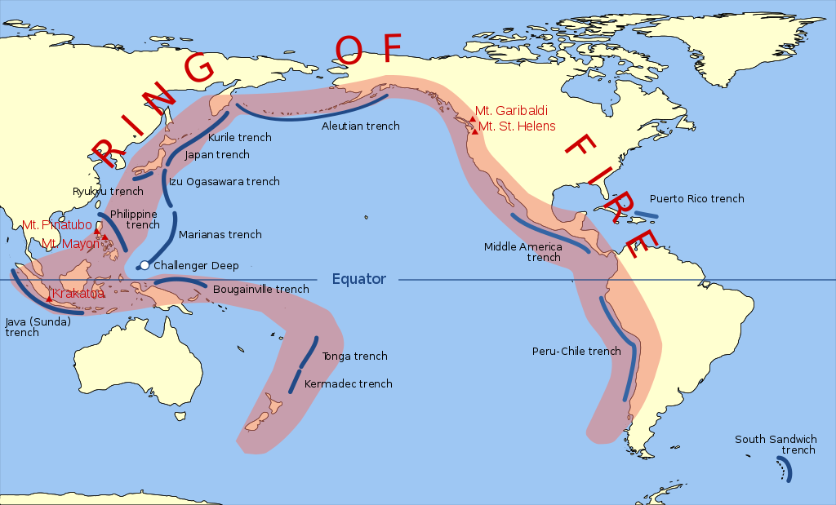
The Pacific Ring of Fire
Looking at the map, one would notice that the Ring of Fire is marked on places where scientists have recognized a chain of volcanic eruptions occurring almost at the same time. The main cause of the eruptions is attributed to the fact that the earth’s surface is made up of a series of tectonic plates that slowly move into and apart from each other (Zongjin, 2020). When this happens, it is then that an earthquake occurs due to the pressure that has accumulated up between the plates.
Activity of any volcanic eruption starts with the formation and escaping of magma to the earth’s surface. Scientists have observed that magma forms in areas characterized with fissures that allow ocean water to flow into the Earth’s mantle where it lowers the layer’s melting point. The molten magma is forced under the earth’s surface by lithostatic pressure that always tries to push it down. However, a magmastatic pressure tries to push it back. The battle between the two forces goes on for long and eventually strain the rock strength of the earth’s crust (Szitkar et al, 2020). When the equilibrium between the forces is thrown off, an explosion occurs and this has been the main cause of the series of volcanic eruptions in the Ring of Fire at the Pacific Ocean.
Magma contains numerous compounds some of which are dissolved. However, some elements such as sulphur are not dissolved instead, they form poisonous bubble of gases. When the bubbles explode, they emit plumes of ash into the stratosphere of the earth. This could be a good reason why stratovolcanoes found in the Ring of Fire emit poisonous gases during eruption. Before explosion, the bubbles tend to lower magma’s density hence increasing buoyant force, which in return pushes upward causing an eruption through the crust. It is important to note here that not all eruptions are caused by rising magmastatic pressure. Some eruptions are caused by what scientists refer to as “unloading” that has been responsible for numerous eruptions such as that of Mount St. Helens in 1980.
Many scientists believe that increased volcanic activities at the Ring of Fire are due to increased tectonic activities, which is also the reason why the region had been experiencing a lot of earthquakes some of which are so strong. Strong earthquakes create fissures on the ocean crust that eventually allow magma to escape. As it continues to pile, the condensed magma causes the earth’s crust to be strained thin as continental plates drift away from each other. When this happens, faults are formed along the plate boundaries and this is considered to be one of the causes of the increased number of earthquakes along the Pacific Ocean Ring of Fire.
According to Beaven et al (2002), every time there are volcanic eruptions on the Northern part of the Pacific plate there are observations of the Pacific plate moving faster than other plates around it. When the plate moves towards the north, it adds a lot stress that causes other plates to crash, for example, the North American plate. The interaction of the lithostatic pressure and magmastatic pressure best describe why eruptions frequently occur at the Ring of Fire. There must be seismic faults caused by frequent earthquake activities. These faults are at the plate boundaries where plates collide and tear apart hence allowing magma to escape to the earth’s surface. The result of all these activities is a series of volcanic eruptions that are frequently accompanied by tsunamis in the region. People cannot just escape from these disasters as the earth continues to experience tectonic plate movements along the Ring of Fire.

References
Beavan, J., Tregoning, P., Bevis, M., Kato, T., & Meertens, C. (2002). Motion and rigidity of the Pacific Plate and implications for plate boundary deformation. Journal of Geophysical Research: Solid Earth, 107(B10), ETG-19.
Szitkar, F., Dyment, J., & Fouquet, Y. (2020). Widespread volcanism Southeast of Futuna Island (SW Pacific Ocean): Near-seafloor magnetic dating and regional consequences. Journal of Volcanology and Geothermal Research, 406, 107064.
USGS (2018). M7.9 Gulf of Alaska Earthquake and Tsunami. Retrieved from < https://www.usgs.gov/news/january-23-2018-m79-gulf-alaska-earthquake-and-tsunami#:~:text=9%20Gulf%20of%20Alaska%20Earthquake%20and%20Tsunami,-Release%20Date%3A%20January&text=One%20week%20ago%2C%20on%20January,miles%20southeast%20of%20Kodiak%20Island>.
Zongjin, M. (2020, August). On Global Tectonics and its Dynamics. In Contemporary Lithospheric Motion Seismic Geology: Proceedings of the 30th International Geological Congress, Volume 5 (p. 1). CRC Press.

